Lexington and Concord
Britain's General Gage had a secret plan.
During the wee hours of April 19, 1775, he would send out regiments of British soldiers quartered in Boston. Their destinations were LEXINGTON, where they would capture Colonial leaders Sam Adams and John Hancock, then CONCORD, where they would seize gunpowder.
But spies and friends of the Americans leaked word of Gage's plan.
Two lanterns hanging from Boston's North Church informed the countryside that the British were going to attack by sea. A series of horseback riders — men such as Paul Revere, WILLIAM DAWES and DR. SAMUEL PRESCOTT — galloped off to warn the countryside that the REGULARS (British troops) were coming.
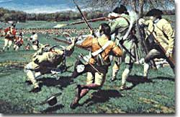

Ready to fight at a moment's notice, minutemen began fighting early in the American Revolution. Their efforts at Lexington and Concord inspired many patriots to take up arms against Britain.

Regulars
It is a myth that Revere and other riders shouted, "The British are coming!" This warning would have confused a good many of the Americans living in the countryside who still considered themselves British. The Regulars were known to be British soldiers.

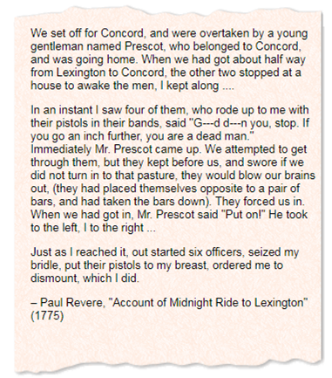

Lexington and the Minutemen

Word spread from town to town, and militias prepared to confront the British and help their neighbors in Lexington and Concord.
These COLONIAL MILITIAS had originally been organized to defend settlers from civil unrest and attacks by French or Native Americans. Selected members of the militia were called MINUTEMEN because they could be ready to fight in a minute's time.
Sure enough, when the advance guard of nearly 240 British soldiers arrived in Lexington, they found about 70 minutemen formed on the LEXINGTON GREEN awaiting them. Both sides eyed each other warily, not knowing what to expect. Suddenly, a bullet buzzed through the morning air.
It was "the shot heard round the world."

Concord
The numerically superior British killed seven Americans on Lexington Green and marched off to Concord with new regiments who had joined them. But American militias arriving at Concord thwarted the British advance.
As the British retreated toward Boston, new waves of Colonial militia intercepted them. Shooting from behind fences and trees, the militias inflicted over 125 casualties, including several officers. The ferocity of the encounter surprised both sides.

The first bloodshed at Lexington and Concord, marked the crossing of a threshold, and the momentum from these events pushed both sides farther apart. Following the battles, neither the British nor the Americans knew what to expect next.
Indignation against the British ran high in the Colonies — for they had shed American blood on American soil. Radicals such as Sam Adams took advantage of the bloodshed to increase tensions through propaganda and rumor-spreading. The Americans surrounded the town of Boston, and the rebel army started gaining many new recruits.
During the battles of Lexington and Concord, 73 British soldiers had been killed and 174 wounded; 26 were missing. LORD PERCY, who led the British back into Boston after the defeat suffered at Concord, wrote back to London, "Whoever looks upon them [THE REBELS] as an irregular mob will be much mistaken." Three British major generals — WILLIAM HOWE, HENRY CLINTON, and "GENTLEMAN JOHNNY" BURGOYNE — were brought to Boston to lend their expertise and experience to the situation.
Benedict Arnold and Ethan Allen Join the Cause
Shortly after the battle, an express rider carried the news to New Haven, Connecticut, where a local militia commander and wealthy shopkeeper named Benedict Arnold demanded the keys to a local powder house.
After arming himself and paying money from his own pocket to outfit a group of militia from Massachusetts, Arnold and his men set off for upstate New York. He was searching for artillery that was badly needed for the Colonial effort and reckoned that he could commandeer some cannon by capturing Fort Ticonderoga, a rotting relic from the French and Indian War.
Up in the HAMPSHIRE GRANTS, part of modern-day Vermont, ETHAN ALLEN who led a group called the GREEN MOUNTAIN BOYS, also had the idea to capture Fort Ticonderoga. The two reluctantly worked together and surprised the poorly manned British fort before dawn on May 10, 1775.
The fort's commander had been asleep and surrendered in his pajamas!

